**Assignment -2**

1. Displaying the star pattern using the loop

* We first created a function in which two nested for loops are used.
* We are taking the input from the user for the number of rows
* In the first nested for loop, we are incrementing the number of stars in the row using the range “n” taken from the user
* In the second nested for loop, we are decrementing the number of stars using the “n-i-1”.

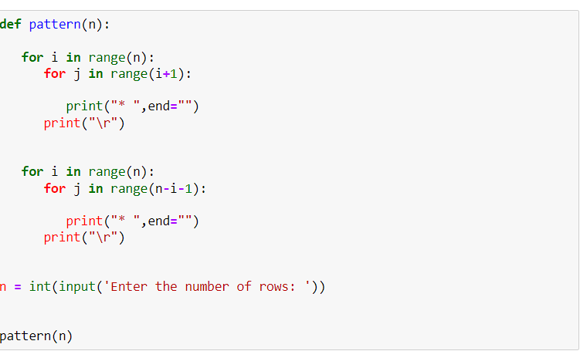

**Output**:

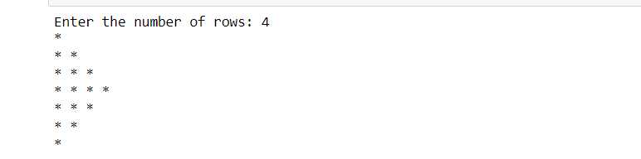

1. Print the elements in the odd indexes.

* Here we are using slicing and indexing to get the elements in the odd indexes.

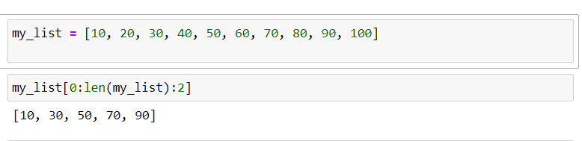

1. Finding the type of elements in a given list

* Using the type method and for loop we are printing the types of all the elements in a list.

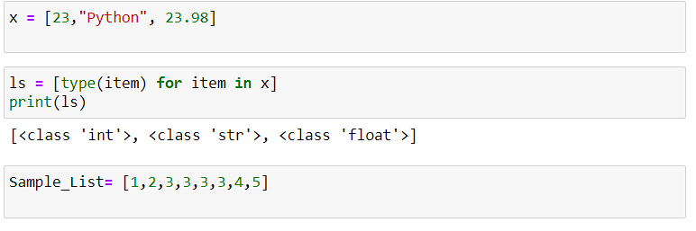

1. Finding the unique items in a list

* Here, we are first converting the list to a set as it can give us unique elements.
* Then we are concerting set back to the list.

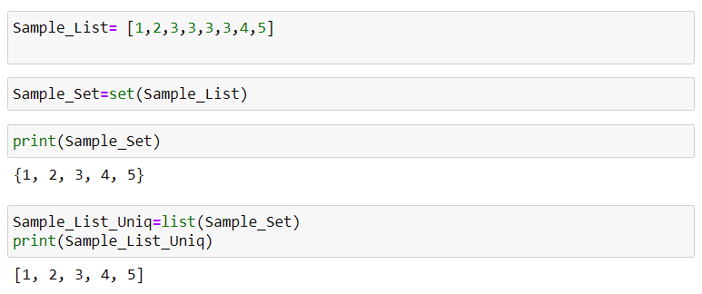

1. Counting the number of upper-case and lower-case letters in a string.

* Here we are using a for loop and checking if the letters are lower or upper using the methods “islower()” and “isupper()”

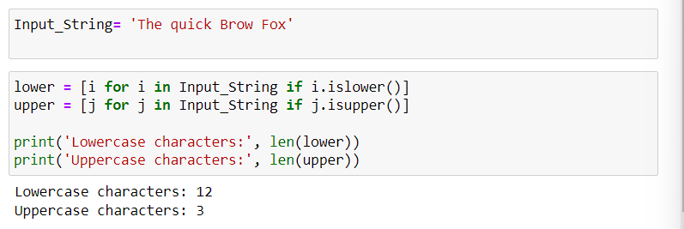

**Video link:** https://youtu.be/qxpf4pq8gXc